**2**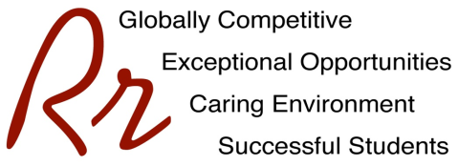

# **Rocky River City Schools**

#### Kensington Intermediate School

# **Grade 4 Supply List – All Teams**

# **2022 - 2023**

The following yearly fee is charged for all students. This fee is for materials and supplies, which will be used during the year. Fees may be paid by CASH or CHECK, made payable to Kensington Intermediate School. To avoid confusion EACH child should have his/her own check or cash for fees. Fees may also be paid along with milk/juice accounts via EZpay found here: <https://www.spsezpay.com/RockyRiver/login.aspx>

**MATERIALS FEE $60.00**

**\*\*INCLUDES $5.00 FOR RECORDER/NOTEBOOK**

**In addition, the following items need to be purchased outside of school:**

* 4 Spiral Notebooks- wide ruled (1 yellow, 1 blue, 1 green, 1 red)
* 1 ½ Inch Three-Ring Binder with Pockets
* 2 two pocket folders (durable plastic pocket folders please)
* 4 Glue Sticks
* 2 Packs of Pencils (Sharpened)
* Hand held pencil sharpener
* 4 Pens – 2 Red & 2 Blue
* Scissors
* Index cards- (girls bring 1 package of 3 x 5” and boys bring 1 package of 4 x 6”)
* Eraser
* Crayons
* Set of Thin Markers
* 2 Thick Chisel Tip Dry Erase Markers (Expo brand preferred- assorted colors)
* Colored Pencils
* 1 Package of 3-ring Dividers (5 dividers for the three ring binder)
* 2 Highlighters
* Ziploc bags- (Last name A-O bring gallon freezer size and Last name P-Z bring sandwich size)
* 2 Large Box of Kleenex
* 1 Container of All-Purpose Clorox or Lysol Antibacterial Wipes
* Tennis Shoes for Fitness/Health
* Book Bag/Pack
* Earbuds or small headphones (Needed to last the full school year)

Separate Supplies for Art Class

* markers (thick)
* colored pencils
* 2 black Sharpies (fine point)
* liquid glue
* pencil
* art shirt

Please do not bring trapper keepers as they do not fit in student desks. Large pencil boxes also do not fit in desks. Backpacks must fit into a locker. Please no rolling backpacks.

**Individual teaching teams may request specific items.**

**PLEASE REPLENISH SUPPLIES AS NEEDED.**